**Chapter 5 – Rome & the Rise of Christianity – 600B.C. – 500 A.D**.

**Section 1. The Rise of Rome**

1. **The Land & Peoples of Italy**

Italy is a peninsula extending about 750 miles (1,207 km) from north to south. It is not very wide, averaging about 120 miles (193 km) across. The Apennine mountain range forms a ridge from north to south down the middle of Italy that divides west from east. Italy has some fairly large fertile plains ideal for farming. Most important are the Po River valley in the north; the plain of Latium, on which the city of Rome is located; and the region of Campania, to the south of Latium.

1. **Impact of Geography**

In the same way as the other civilizations we have examined, geography played an important role in the development of Rome. The Apennines are less rugged than the mountain ranges of Greece and did not divide the Italian peninsula into many small, isolated communities. Italy also had more land for farming than did Greece, enabling it to support a large population.

The location of the city of Rome was especially favorable to early settlers. Located about 18 miles (29 km) inland on the Tiber River, Rome had a way to the sea. However, it was far enough inland to be safe from pirates. Because it was built on seven hills, it was easily defended. In addition, it was situated where the Tiber could be easily crossed. Thus, it became a natural crossing point for north-south traffic in western Italy. All in all, Rome had a good central location in Italy from which to expand.

The Italian peninsula juts into the Mediterranean, making it an important crossroads between the western and eastern Mediterranean Sea. Once Rome had unified Italy, it easily became involved in Mediterranean affairs. After the Romans had established their Mediterranean empire, governing it was made easier by Italy’s central location.

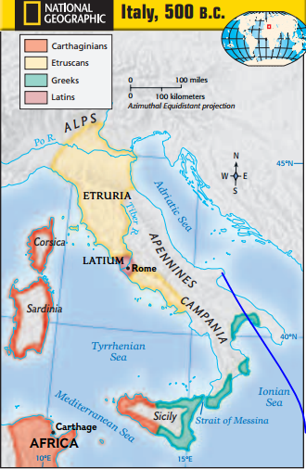

1. **Peoples of Italy**

Indo-European peoples moved into Italy during the period from about 1500 to 1000 B.C. We know little about these peoples, but we do know that one such group was the Latins, who lived in the region of Latium. These people spoke Latin, which, like Greek, is an Indo-European language. They were herders and farmers who lived in settlements consisting of huts on the tops of Rome’s hills. After about 800 B.C., other people also began settling in Italy—the two most notable being the Greeks and the Etruscans.

The Greeks came to Italy in large numbers during the age of Greek colonization (750–550 B.C.). They settled in southern Italy and then slowly moved around the coast and up the peninsula. The eastern two-thirds of Sicily, an island south of the Italian peninsula, was also occupied by the Greeks. The Greeks had much influence on Rome. They cultivated olives and grapes, passed on their alphabet, and gave the Romans artistic and cultural models through their sculpture, architecture, and literature.

The early development of Rome, however, was influenced most by the Etruscans, who were located north of Rome in Etruria. After 650 B.C., they expanded into north-central Italy and came to control Rome and most of Latium. The Etruscans found Rome a village but launched a building program that turned it into a city. Etruscan dress—the toga and short cloak—was adopted by the Romans. The organization of the Roman army also was borrowed from the Etruscans**.**

1. **The Roman Republic**

Roman tradition maintains that early Rome (753–509 B.C.) was under the control of seven kings and that two of the last three kings were Etruscans. Historians know for certain that Rome did fall under Etruscan influence during this time. In 509 B.C., the Romans overthrew the last Etruscan king and established a republic, a form of government in which the leader is not a monarch and certain citizens have the right to vote. This was the beginning of a new era in Rome’s history.

1. **War & conquest**

At the beginning of the republic, Rome was surrounded by enemies. For the next two hundred years, the city was engaged in almost continuous warfare.

In 338 B.C., Rome crushed the Latin states in Latium. During the next 50 years, the Romans waged a fierce struggle against people from the central Apennines, some of whom had settled south of Rome. Rome was again victorious. The conquest gave the Romans control over a large part of Italy.

It also brought them into direct contact with the Greek communities of southern Italy. Soon, the Romans were at war with these Greek cities. By 264 B.C., they had overcome the Greeks and completed their conquest of southern Italy. After defeating the remaining Etruscan states to the north over the next three years, Rome had conquered virtually all of Italy.

To rule Italy, the Romans devised the Roman Confederation. Under this system, Rome allowed some peoples—especially Latins—to have full Roman citizenship. Most of the remaining communities were made allies. They remained free to run their own local affairs but were required to provide soldiers for Rome. The Romans made it clear that loyal allies could improve their status and even become Roman citizens. The Romans made the conquered peoples feel they had a real stake in Rome’s success.

1. **Why Rome Was Successful**

Romans believed that their early ancestors were successful because of their sense of duty, courage, and discipline. The Roman historian Livy, writing in the first century B.C., provided a number of stories to teach Romans the virtues that had made Rome great. His account of Cincinnatus, a simple farmer who was chosen as a temporary ruler to save Rome from attack, is one such example.

Looking back today, how can we explain Rome’s success in gaining control of the entire Italian peninsula? First, the Romans were good diplomats. They were shrewd in extending Roman citizenship and allowing states to run their own internal affairs. Although diplomatic, however, they could be firm, and even cruel when necessary, crushing rebellions without mercy.

Second, the Romans excelled in military matters. They were not only accomplished soldiers but also persistent ones. The loss of an army or a fleet did not cause them to quit but instead spurred them on to build new armies and new fleets. In addition, they were brilliant strategists. As they conquered, the Romans built colonies—fortified towns—throughout Italy. By building roads to these towns and thus connecting them, the Romans could move troops quickly throughout their conquered territory.

Finally, in law and politics, as in conquest, the Romans were practical. They did not try to build an ideal government but instead created political institutions in response to problems, as the problems arose.

1. **The Roman State**

The Romans had been ruled by kings under the Etruscans. As a result, they distrusted kingship and devised a very different system of government.

1. **Government of Rome**

Early Rome was divided into two groups or orders—the patricians

and the plebeians (plih•BEE•uhns). The patricians were great landowners, who became Rome’s ruling class. Less wealthy landholders, craftspeople, merchants, and small farmers were part of a larger group called plebeians.

Men in both groups were citizens and could vote, but only the patricians could be elected to governmental offices. The chief executive officers of the Roman Republic were the consuls and praetors (PREE•tuhrs). Two consuls, chosen every year, ran the government and led the Roman army into battle. The praetor was in charge of civil law—law as it applied to Roman citizens. As the Romans’ territory expanded, another praetor was added to judge cases in which one or both people were noncitizens. The Romans also had a number of officials who had special duties, such as supervising the treasury.

The Roman Senate came to hold an especially important position in the Roman Republic. It was a select group of about three hundred patricians who served for life. At irst, the Senate’s only role was to advise government officials. However, the advice of the Senate carried a great deal of weight. By the third century B.C., it had the force of law.

The Roman Republic had several people’s assemblies in addition to the Senate. By far the most important of these was the centuriate assembly. The centuriate assembly elected the chief officials, such as consuls and praetors, and passed laws. Because it was organized by classes based on wealth, the wealthiest citizens always had a majority. The council of the plebs was the assembly for plebeians only, and it came into being as a result of the struggle between the two social orders in Rome.

1. **The Struggle of the Orders**

There was often conflict between the patricians and the plebeians in the early Roman Republic. Children of patricians and plebeians were forbidden to marry each other. Plebeians resented this situation, especially since they served in the Roman army that protected the Republic. They thought that they deserved both political and social equality with the patricians.

The struggle between the patricians and plebeians dragged on for hundreds of years. Ultimately, it led to success for the plebeians. A popular assembly for plebeians only, the council of the plebs, was created in 471 B.C. New officials, known as tribunes of the plebs, were given the power to protect the plebeians. In the fourth century B.C., plebeians were permitted to become consuls. Finally, in 287 B.C., the council of the plebs received the right to pass laws for all Romans.

By 287 B.C., all male Roman citizens were supposedly equal under the law. In reality, however, a few wealthy patrician and plebeian families formed a new senatorial ruling class that came to dominate the political offices. The Roman Republic had not become a democracy.

1. **Roman Law**

One of Rome’s chief gifts to the Mediterranean world of its day and to later generations was its system of law. Rome’s first code of laws was the Twelve Tables, which was adopted in 450 B.C. This code was a product of a simple farming society and proved inadequate for later Roman needs. From the Twelve Tables, the Romans developed a more sophisticated system of civil law. This system applied only to Roman citizens, however.

As Rome expanded, legal questions arose that involved both Romans and non-Romans. The Romans found that although some of their rules of civil law could be used in these cases, special rules were often needed. These rules gave rise to a body of law known as the Law of Nations. The Romans came to identify the Law of Nations with natural law, or universal law based on reason. This enabled them to establish standards of justice that applied to all people.

These standards of justice included principles still recognized today. A person was regarded as innocent until proved otherwise. People accused of wrongdoing were allowed to defend themselves before a judge. A judge, in turn, was expected to weigh evidence carefully before arriving at a decision. These principles lived on long after the fall of the Roman Empire.

1. **Rome Conquers the Mediterranean**

After their conquest of Italy, the Romans found themselves face to face with a strong power in the Mediterranean—the state of Carthage. Carthage had been founded around 800 B.C. on the coast of North Africa by Phoenicians. The state had created an enormous trading empire in the western Mediterranean. By the third century B.C., the Carthaginian Empire included the coast of northern Africa, southern Spain, Sardinia, Corsica, and western Sicily. With its control of western Mediterranean trade, Carthage was the largest and richest state in the area.

The presence of Carthaginians in Sicily, an island close to the Italian coast, made the Romans fearful. In 264 B.C., the two powers began a lengthy struggle for control of the western Mediterranean.

**The First Punic War**

Rome’s first war with Carthage began in 264 B.C. It is called the First Punic War, after the Latin word for Phoenician, punicus. The war started when the Romans sent an army to Sicily. The Carthaginians, who thought of Sicily as part of their empire, considered this an act of war. Both sides became determined to conquer Sicily.

The Romans—a land power—realized that they could not win the war without a navy and created a large naval fleet. After a long struggle, a Roman fleet defeated the Carthaginian navy off the coast of Sicily, and the war came to an end. In 241 B.C., Carthage gave up all rights to Sicily and paid a fine to the Romans. Sicily became the first Roman province.

Carthage vowed revenge, however, and added new lands in Spain to make up for the loss of Sicily. The Romans encouraged one of Carthage’s Spanish allies to revolt against Carthage. In response, Hannibal, the greatest of the Carthaginian generals, struck back, beginning the Second Punic War (218 to 201 B.C.).

1. **The Second Punic war**

Hannibal decided that the Carthaginians would bring the war home to the Romans. Hannibal entered Spain, moved east, and crossed the Alps with an army of about 46,000 men, a large number of horses, and 37 battle elephants. The Alps took a toll on the Carthaginian army; most of the elephants did not survive. The remaining army, however, posed a real threat to the Romans.

In 216 B.C., the Romans decided to meet Hannibal head on. It was a serious mistake. At Cannae (KA•nee), the Romans lost an army of almost forty thousand men. On the brink of disaster, Rome refused to surrender and raised yet another army.

In a brilliant military initiative, Rome decided to invade Carthage rather than fight Hannibal in Italy. This strategy forced the Carthaginians to recall Hannibal from Italy. At the Battle of Zama (ZAY•muh) in 202 B.C., the Romans crushed Hannibal’s forces, and the war was over. Carthage lost Spain, which became a Roman province. Rome had become the dominant power in the western Mediterranean.

**More Conquests**

Fifty years later, the Romans fought their third and final struggle with Carthage, the Third Punic War. For years, a number of prominent Romans had called for the complete destruction of Carthage.

In 146 B.C., Carthage was destroyed. For 10 days, Roman soldiers burned and demolished all of the city’s buildings. The inhabitants—fifty thousand men, women, and children—were sold into slavery. The territory of Carthage became a Roman province called Africa.

During its struggle with Carthage, Rome also battled the Hellenistic states in the eastern Mediterranean. The Fourth Macedonian War ended in 148 B.C., and Macedonia was made a Roman province. Two years later, Greece was placed under the control of the Roman governor of Macedonia. In 129 B.C., Pergamum became Rome’s first province in Asia. Rome was now master of the Mediterranean Sea.

**Section 2. From Republic to Empire**

1. **Growing Inequity & Unrest**

By the second century B.C., the Senate had become the real governing body of the Roman state. Members of the Senate were drawn mostly from the landed aristocracy. They remained senators for life and held the chief offices of the republic. The Senate directed the wars of the third and second centuries B.C. and took control of both foreign and domestic policy, including financial affairs. The Senate and political offices were increasingly controlled by a small circle of wealthy and powerful families.

Of course, these aristocrats formed only a tiny minority of the Roman people. The backbone of the Roman state and army had always been the small farmers. Over a period of time, however, many small farmers had found themselves unable to compete with large, wealthy landowners and had lost their lands. As a result, many of these small farmers drifted to the cities, especially Rome, forming a large class of landless poor.

Some aristocrats tried to remedy this growing economic and social crisis. Two brothers, Tiberius and Gaius Gracchus (GRA•kuhs), believed that the basic cause of Rome’s problems was the decline of the small farmer. To remedy the problem, they urged the council of the plebs to pass land-reform bills that called for the government to take back public land held by large landowners and give it to landless Romans.

Many senators, themselves large landowners whose estates included large areas of public land, were furious. A group of senators took the law into their own hands and killed Tiberius in 133 B.C. His brother Gaius later suffered the same fate. The attempts of the Gracchus brothers to bring reforms had opened the door to more instability and more violence. Changes in the Roman army soon brought even worse problems.

1. **A New Role for the Army**

In 107 B.C., a Roman general named Marius became consul and began to recruit his armies in a new way. For a long time, the Roman army had been made up of small farmers who were landholders. Now Marius recruited volunteers from the urban and rural poor who owned no property. To recruit them, he promised them land. These volunteers swore an oath of loyalty to the general, not to the Roman state. As a result, Marius created a new type of army that was not under government control. In addition, generals were forced to become involved in politics in order to get laws passed that would provide the land they needed for their veterans.

Marius left a powerful legacy. He had created a new system of military recruitment that placed much power in the hands of the individual generals.

Lucius Cornelius Sulla was the next general to take advantage of the new military system. The Senate had given him command of a war in Asia Minor. The council of the plebs tried to transfer command to Marius, and a civil war broke out. Sulla won and seized Rome itself in 82 B.C., conducting a reign of terror to wipe out all opposition. Then Sulla restored power to the hands of the Senate and eliminated most of the powers of the popular assemblies.

Sulla hoped that he had created a firm foundation to restore a traditional Roman republic governed by a powerful Senate. His real legacy was quite different from what he had intended, however. His example of using an army to seize power would prove most attractive to ambitious men.

1. **The Collapse of the Republic**

For the next 50 years (82–31 B.C.), Roman history was characterized by civil wars as a number of individuals competed for power. Three men—Crassus, Pompey, and Julius Caesar—emerged as victors.

Crassus was known as the richest man in Rome. Pompey had returned from a successful command in Spain as a military hero. Julius Caesar also had a military command in Spain. The combined wealth and power of these three men was enormous and enabled them to dominate the political scene and achieve their basic aims.

1. **The First Triumvirate**

In 60 B.C., Caesar joined with Crassus and Pompey to form the First Triumvirate. A triumvirate is a government by three people with equal power. Pompey received a command in Spain, Crassus was given a command in Syria, and Caesar was granted a special military command in Gaul (modern France)—where he achieved success and distinction as a military leader.

When Crassus was killed in battle in 53 B.C., however, only two powerful men were left. Leading senators decided that rule by Pompey alone would be to their benefit. They voted for Caesar to lay down his command.

Caesar refused. During his time in Gaul, he had gained military experience, as well as an army of loyal veterans. He chose to keep his army and moved into Italy by illegally crossing the Rubicon, the river that formed the southern boundary of his province. (“Crossing the Rubicon” is a phrase used today to mean being unable to turn back.)

Caesar marched on Rome, starting a civil war between his forces and those of Pompey and his allies. The defeat of Pompey’s forces left Caesar in complete control of the Roman government.

Caesar was officially made dictator in 45 B.C. A dictator is an absolute ruler. Realizing the need for reforms, Caesar gave land to the poor and increased the Senate to 900 members. By filling it with many of his supporters and increasing the number of members, he weakened the power of the Senate.

Caesar planned much more in the way of building projects and military adventures to the east. However, in 44 B.C., a group of leading senators assassinated him.

1. **The Second Triumvirate**

A new struggle for power followed Caesar’s death. Three men—Octavian, Caesar’s heir and grandnephew; Antony, Caesar’s ally and assistant; and Lepidus, who had been commander of Caesar’s cavalry—joined forces to form the Second Triumvirate. Within a few years after Caesar’s death, however, only two men divided the Roman world between them. Octavian took the west; Antony, the east.

The empire of the Romans, large as it was, was still too small for two masters. Octavian and Antony soon came into conflict. Antony allied himself with the Egyptian queen Cleopatra VII. Like Caesar before him, Antony had fallen deeply in love with her. At the Battle of Actium in Greece in 31 B.C., Octavian’s forces smashed the army and the navy of Antony and Cleopatra. Both fled to Egypt, where they committed suicide a year later:

“Antony was the first to commit suicide, by the sword. Cleopatra threw herself at Octavian’s feet, and tried her best to attract his gaze: in vain, for his self control enabled him to ignore her beauty. It was not her life she was after, . . . but a portion of her kingdom. When she realized this was hopeless. . . she took advantage of her guard’s carelessness to get herself into the royal tomb. Once there, she put on the royal robes . . . and lay down in a richly perfumed coffin beside her Antony. Then she applied poisonous snakes to her veins and passed into death as though into a sleep.”

Octavian, at the age of 32, stood supreme over the Roman world. The civil wars had ended. So had the republic. The period beginning in 31 B.C. and lasting until A.D. 14 came to be known as the Age of Augustus.

1. **The Age of Augustus**

In 27 B.C., Octavian proclaimed the “restoration of the Republic.” He knew that only traditional republican forms would satisfy the Senate. At the same time, he was aware that the republic could not be fully restored. Although he gave some power to the Senate, Octavian in fact became the first Roman emperor. In 27 B.C., the Senate awarded him the title of Augustus—“the revered one,” a fitting title in view of his power.

Augustus proved to be highly popular, but his continuing control of the army was the chief source of his power. The Senate gave Augustus the title imperator, or commander in chief. Imperator gave us our word emperor.

Augustus maintained a standing army of 28 legions, or about 150,000 men. (A legion was a military unit of about 5,000 troops.) Only Roman citizens could be legionnaires (members of a legion). Subject peoples could serve as auxiliary forces, which numbered around 130,000 under Augustus. Augustus also set up a praetorian guard of roughly 9,000 men who had the important task of guarding the emperor.

Augustus stabilized the frontiers of the Roman Empire, conquering many new areas. His attempt to conquer Germany failed, however, when three Roman legions under Varus were massacred by German warriors. These defeats in Germany taught Augustus that Rome’s power was not unlimited. This knowledge devastated him. For months, he would beat his head on a door, shouting, “Varus, give me back my legions!”

1. **The Early Empire**

Beginning in A.D. 14, a series of new emperors ruled Rome. This period, ending in A.D. 180, is called the Early Empire.

**Emperors of the Early Empire**

Augustus’s new political system allowed the emperor to select his successor from his natural or adopted family. The first four emperors after Augustus came from his family. They were Tiberius, Caligula, Claudius, and Nero. During their reigns, these emperors took over more and more of the responsibilities that Augustus had given to the Senate. At the same time, as the emperors grew more powerful, they became more corrupt.

Nero, for example, had people killed if he wanted them out of the way—including his own mother. Without troops, the senators were unable to oppose his excesses, but the Roman legions finally revolted. Nero, abandoned by his guards, chose to commit suicide by stabbing himself in the throat after allegedly uttering these final words: “What an artist the world is losing in me.”

At the beginning of the second century, a series of five so-called good emperors came to power. They were Nerva, Trajan, Hadrian, Antoninus Pius, and Marcus Aurelius. These emperors created a period of peace and prosperity known as the Pax Romana—the “Roman Peace.” The Pax Romana lasted for almost a hundred years. These rulers treated the ruling classes with respect, ended arbitrary executions, maintained peace in the empire, and supported domestic policies generally helpful to the empire. By adopting capable men as their sons and successors, the first four good emperors reduced the chances of succession problems.

Under the five good emperors, the powers of the emperor continued to expand at the expense of the Senate. Officials who were appointed and directed by the emperor took over the running of the government. The good emperors also created new programs to help the people. Trajan, for example, created a program that provided state funds to assist poor parents in the raising and education of their children. The good emperors were widely praised for their building programs. Trajan and Hadrian were especially active in building public works—aqueducts, bridges, roads, and harbor facilities—throughout the provinces and in Rome.

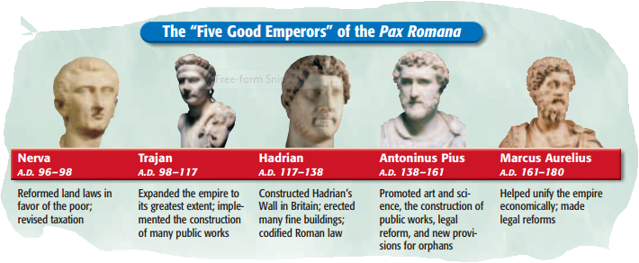

1. **Extent of the Empire**

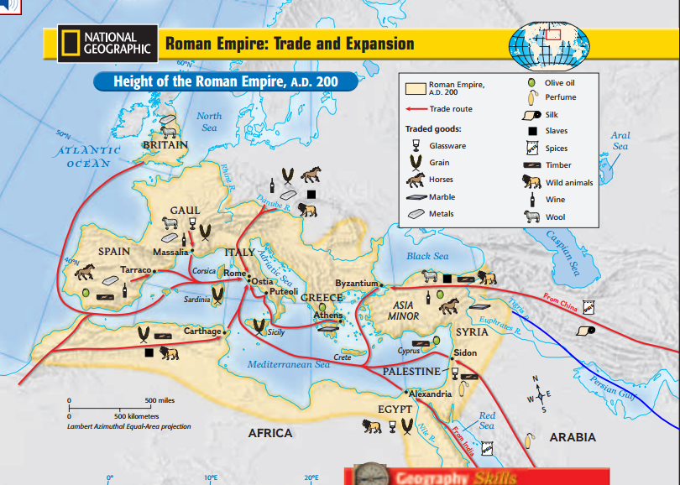

Rome expanded further during the period of the Early Empire. Trajan extended Roman rule into Dacia (modern Romania), Mesopotamia, and the Sinai Peninsula. His successors, however, realized that the empire was too large to be easily governed.

withdrew Roman forces from much of Mesopotamia and also went on the defensive in his frontier policy. He strengthened the fortifications along a line connecting the Rhine and Danube Rivers. He also built a defensive wall (Hadrian’s Wall) about 74 miles (118 km) long across northern Britain to keep out the Picts and the Scots. By the end of the second century, it became apparent that it would be more and more difficult to defend the empire. Roman forces were located in permanent bases behind the frontiers.

At its height in the second century, the Roman Empire was one of the greatest states the world had ever seen. It covered about three and a half million square miles (about 9.1 million square km) and had a population that has been estimated at more than fifty million.

The emperors and the imperial government provided a degree of unity. Much leeway was given to local customs, and the privileges of Roman citizenship were granted to many people throughout the empire. In A.D. 212, the emperor Caracalla gave Roman citizenship to every free person in the empire.

Cities were important in the spread of Roman culture, Roman law, and the Latin language. Provincial cities resembled each other with their temples, markets, and public buildings. Local city officials acted as Roman agents, performing many government duties, especially taxation.

Latin was the language of the western part of the empire, whereas Greek was used in the east. Roman culture spread to all parts of the empire and freely mixed with Greek culture. The result has been called Greco-Roman civilization.

1. **Economic & Social Conditions**

The Early Empire was a period of much prosperity, with internal peace leading to high levels of trade. Merchants from all over the empire came to the chief Italian ports of Puteoli (pyuh•TEE•uh•LY) on the Bay of Naples and Ostia at the mouth of the Tiber. Trade went beyond the Roman frontiers as well and included even silk goods from China. Large quantities of grain were imported, especially from Egypt, to feed the people of Rome. Luxury items poured in to satisfy the wealthy upper classes.

Despite the active trade and commerce, however, farming remained the chief occupation of most people and the underlying basis of Roman prosperity. Large landed estates, called latifundia , dominated farming in southern and central Italy. These estates raised sheep and cattle on a large scale using mostly slave labor. Small peasant farms continued to exist in northern Italy.

An enormous gulf separated rich and poor in Roman society. The upper classes lived lives of great leisure and luxury in their villas and on their vast estates. Small farmers often became dependent on the huge estates of their wealthy neighbors. In the cities, many poor citizens worked in shops and markets. Thousands of unemployed people depended on the emperor’s handouts of grain to survive.

**Section 3. Culture & Society in Ancient Rome**

1. **Roman Art & Architecture**

During the third and second centuries B.C., the Romans adopted many features of the Greek style of art. They developed a taste for Greek statues, which they placed not only in public buildings but also in their private houses. Reproductions of Greek statues became popular once the supply of original works ran low. While Greek sculptors aimed for an ideal appearance in their figures, Roman sculptors produced realistic statues that included even unpleasant physical details.

The Romans excelled in architecture, a highly practical art. Although they continued to use Greek styles such as colonnades and rectangular buildings, the Romans also used forms based on curved lines: the arch, vault, and dome. The Romans were the first people in antiquity to use concrete on a massive scale. Using concrete along with the new architectural forms made it possible for the Romans to construct huge buildings undreamed of by the Greeks.

The remarkable engineering skills of the Romans were also put to use in constructing roads, bridges, and aqueducts. The Romans built a network of some 50,000 miles (80,450 km) of roads throughout the empire. In Rome, almost a dozen aqueducts kept a population of one million supplied with water. The Romans were superb builders.

1. **Roman Literature**

Although there were many talented writers, the high point of Latin literature was reached in the Age of Augustus. Indeed, the Augustan Age has been called the golden age of Latin literature.

The most distinguished poet of the Augustan Age was Virgil. The son of a small landholder in northern Italy near Mantua, he welcomed the rule of Augustus and wrote his greatest work, the Aeneid (ih• NEE•uhd), in honor of Rome. In the poem, the character of Aeneas is portrayed as the ideal Roman—his virtues are duty, piety, and faithfulness. Virgil’s overall purpose was to show that Aeneas had fulfilled his mission to establish the Romans in Italy and thereby start Rome on its divine mission to rule the world.

Another prominent Augustan poet was Horace, a friend of Virgil’s. He was a sophisticated writer who enjoyed pointing out to his fellow Romans the “follies and vices of his age.” In the Satires, Horace directs attacks against job dissatisfaction and greed. (“How does it happen, Maecenas, that no man alone is content with his lot?”) Horace mostly laughs at the weaknesses of humans.

The most famous Latin prose work of the golden age was written by the historian Livy, whose masterpiece was the History of Rome. In 142 books, Livy traced the history of Rome from the foundation of the city to 9 B.C. Only 35 of the books have survived. Livy saw history in terms of moral lessons. He stated in the preface:

“The study of history is the best medicine for a sick mind; for in history you have a record of the infinite variety of human experience plainly set out for all to see; and in that record you can find for yourself and your country both examples and warnings: fine things to take as models, base things, rotten through and through, to avoid.”

Livy’s history celebrated Rome’s greatness. He built scene upon scene that not only revealed the character of the chief figures but also demonstrated the virtues that had made Rome great. Livy had a serious weakness as a historian: he was not always concerned about the factual accuracy of his stories. He did tell a good tale, however, and his work became the standard history of Rome for a long time.

1. **The Roman Family**

At the heart of the Roman social structure stood the family, headed by the paterfamilias—the dominant male. The household also included the wife, sons with their wives and children, unmarried daughters, and slaves.

Unlike the Greeks, the Romans raised their children at home. All Roman upper-class children (boys and girls) were expected to learn to read. The father was the chief figure in providing for the education of his children. He made the decision whether to teach his children himself, acquire a teacher for them, or send them to school. Teachers were often Greek slaves because upper-class Romans had to learn Greek as well as Latin to prosper in the empire.

Roman boys learned reading and writing, moral principles and family values, law, and physical training to prepare them to be soldiers. The end of childhood for Roman males was marked by a special ceremony. At the age of 16, a young Roman man exchanged his purple-edged toga for a plain white toga—the toga of manhood.

Some parents in upper-class families provided education for their daughters by hiring private tutors or sending the girls to primary schools. However, at the age when boys were entering secondary schools, girls were entering into marriage.

1. **Attitudes Toward Women**

Like the Greeks, Roman males believed that the weakness of females made it necessary for women to have male guardians. The paterfamilias had that responsibility. When he died, his sons or nearest male relatives assumed the role of guardian. Fathers also arranged the marriages of their daughters.

For females, the legal minimum age for marriage was 12, although 14 was a more common age in practice (for males, the legal minimum age was 14, although most men married later). Although some Roman doctors warned that pregnancies could be dangerous for young girls, early marriages continued.

Traditionally, Roman marriages were meant to be for life, but divorce was introduced in the third century B.C. and became fairly easy to obtain. Either husband or wife could ask for a divorce. No one needed to prove the breakdown of the marriage.

1. **Changing Roles**

By the second century A.D., important changes were occurring in the Roman family. The paterfamilias no longer had absolute authority over his children. He could not sell his children into slavery or have them put to death. The husband’s absolute authority over his wife also disappeared. By the late second century, women were no longer required to have guardians.

Upper-class Roman women in the Early Empire had considerable freedom and independence. They had the right to own, inherit, and sell property. Unlike Greek wives, Roman wives were not segregated from males in the home. They were appreciated as enjoyable company and were at the center of household social life.

Outside their homes, upper-class women could attend races, the theater, and events in the amphitheater. In the latter two places, however, they were forced to sit in separate female sections. Women of rank were still accompanied by maids and companions when they went out. Women could not officially participate in politics, but a number of important women influenced politics through their husbands.

1. **Slavery**

Slavery was common throughout the ancient world, but no people had more slaves or relied so much on slave labor as the Romans did. Before the third century B.C., a small Roman farmer might possess one or two slaves, who would help farm his few acres and work in the house. These slaves would most likely be from Italy and be regarded as part of the family household. The very rich would have many slaves.

1. **The Use of slaves**

The Roman conquest of the Mediterranean brought a drastic change in the use of slaves. Large numbers of foreign peoples who had been captured in different wars were brought back to Italy as slaves. Greek slaves were in much demand as tutors, musicians, doctors, and artists. Roman businessmen would employ them as shop assistants or craftspeople. Many slaves of all nationalities were used as household workers, such as cooks, valets, waiters, cleaners, and gardeners.

Slaves built roads and public buildings, and farmed the large estates of the wealthy. The conditions under which these slaves lived were often pitiful. One Roman writer argued that it was cheaper to work slaves to death and then replace them than to treat them well.

1. **Slave Revolts**

Some slaves revolted against their owners and even murdered them, causing some Romans to live in great fear of their slaves. The murder of a master by a slave might mean the execution of all the other household slaves.

The most famous slave revolt in Italy occurred in 73 B.C. Led by the gladiator Spartacus, the revolt broke out in southern Italy and involved seventy thousand slaves. Spartacus managed to defeat several Roman armies before being trapped and killed in 71 B.C. Six thousand followers of Spartacus were crucified (put to death by nailing to a cross).

1. **Daily life in the City of Rome**

At the center of the colossal Roman Empire was the ancient city of Rome. Truly a capital city, Rome had the largest population of any city in the empire— close to one million by the time of Augustus. For anyone with ambitions, Rome was the place to be. People from all over the empire resided there.

1. **Living conditions**

Rome was an overcrowded and noisy city. Because of the congestion, cart and wagon traffic was banned from the streets during the day. However, the noise from the traffic at night often made sleep difficult. Walking in Rome at night was also dangerous. Augustus had organized a police force, but people could be assaulted or robbed. They could also be soaked by filth thrown out of the upper-story windows of Rome’s massive apartment buildings.

An enormous gulf existed between rich and poor. The rich had comfortable villas, while the poor lived in apartment blocks called insulae, which might be six stories high. Constructed of concrete walls with wooden beam floors, these buildings were usually poorly built and often collapsed.

Fire was a constant threat in the insulae because of the use of movable stoves, torches, candles, and lamps within the rooms for heat and light. Once started, fires were extremely difficult to put out. The famous fire of A.D. 64, which Nero was falsely accused of starting, destroyed a good part of the city.

High rents forced entire families to live in one room. There was no plumbing or central heating. These conditions made homes uncomfortable. As a result, many poor Romans spent most of their time outdoors in the streets.

1. **Public Programs**

Rome boasted public buildings unequaled anywhere in the empire. Its temples, markets, baths, theaters, governmental buildings, and amphitheaters gave parts of the city an appearance of grandeur and magnificence.

it was the center of a great empire, Rome had serious problems. Beginning with Augustus, the emperors provided food for the city poor. About two hundred thousand people received free grain. Even so, conditions remained grim for the poor.

Entertainment was provided on a grand scale for the inhabitants of Rome. The poet Juvenal said of the Roman masses, “But nowadays, with no vote . . . , their motto is ‘Couldn’t care less.’ Time was when their vote elected generals, heads of state, commanders of legions: but now. . . there’s only two things that concern them: Bread and Circuses.”

Public spectacles were provided by the emperor as part of the great religious festivals celebrated by the state. The festivals included three major types of entertainment. At the Circus Maximus, horse and chariot races attracted hundreds of thousands. Dramatic performances were held in theaters. The most famous of all the public spectacles, however, were the gladiatorial shows.

**Section 4. Development of Christianity**

1. **Background: Roman Religion**

Augustus brought back traditional festivals and ceremonies to revive the Roman state religion, which had declined during the turmoil of the late Roman Republic. The official state religion focused on the worship of a number of gods and goddesses, including Jupiter, Juno, Minerva, and Mars. (In addition, beginning with Augustus, emperors were often officially made gods by the Roman Senate, thus bolstering support for the emperors.)

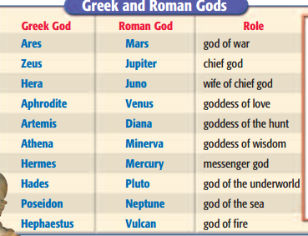

The Romans believed that the observation of proper ritual by state priests brought them into a right relationship with the gods. This guaranteed peace and prosperity. Indeed, the Romans believed that their success in creating an empire meant that they had earned the favor of the gods. As the politician Cicero claimed in the first century B.C., “We have overcome all the nations of the world, because we have realized that the world is directed and governed by the gods.”

At the same time, the Romans were tolerant of other religions. They allowed the worship of native gods and goddesses throughout their provinces. They even adopted some of the local gods.

After the Romans conquered the states of the Hellenistic east, religions from those regions flooded the western Roman world. The desire for a more emotional spiritual experience drew many people to these religions. They promised their followers an entry into a higher world of reality and the promise of a future life superior to the present one. It was believed that, by participating in these ceremonies, a person could communicate with spiritual beings and open the door to life after death.

1. **The Jewish Background**

In Hellenistic times, the Jewish people had been given considerable independence. By A.D. 6, however, Judaea, which embraced the lands of the old Jewish kingdom of Judah, had been made a Roman province and been placed under the direction of a Roman official called a procurator.

Unrest was widespread in Judaea, but the Jews differed among themselves about Roman rule. The priestly Sadducees favored cooperation with Rome. The scholarly Pharisees held that close observance of religious law would protect Jewish identity from Roman influences. The Essenes lived apart from society, sharing goods in common. Like many other Jews, they waited for God to save Israel from oppression. The Zealots, however, called for the violent overthrow of Roman rule. In fact, a Jewish revolt began in A.D. 66, only to be crushed by the Romans four years later. The Jewish temple in Jerusalem was destroyed.

1. **The Message of Jesus**

A few decades before the revolt, a Jewish prophet named Jesus traveled and preached throughout Judaea and neighboring Galilee.

Jesus believed that his mission was to complete the salvation that God had promised to Israel throughout its history. He stated:

“Do not think that I have come to abolish the Law or the Prophets; I have not come to abolish them but to fulfill them.” According to Jesus, what was important was not strict adherence to the letter of the law but the transformation of the inner person: “So in everything, do to others what you would have them do to you, for this sums up the Law and the Prophets.”

God’s command was to love God and one another. Jesus said, “Love the Lord your God with all your heart and with all your soul and with all your mind and with all your strength. This is the first commandment. The second is this: Love your neighbor as yourself.” Jesus voiced the ethical concepts—humility, charity, and love toward others—that would later shape the value system of Western civilization.

Jesus’ preaching eventually stirred controversy. Some people saw Jesus as a potential revolutionary who might lead a revolt against Rome. Jesus’ opponents finally turned him over to Roman authorities. The procurator Pontius Pilate ordered Jesus’ crucifixion.

After the death of Jesus, his followers proclaimed that he had risen from death and had appeared to them. They believed Jesus to be the Messiah (anointed one), the long expected deliverer who would save Israel from its foes.

1. **The Spread of Christianity**

Christianity began as a movement within Judaism. After the reports that Jesus had overcome death, the Christian movement won followers in Jerusalem and throughout Judaea and Galilee.

Prominent apostles, or leaders, arose in early Christianity. One was Simon Peter, a Jewish fisherman who had become a follower of Jesus during Jesus’ lifetime. Peter was recognized as the leader of the apostles. Another major apostle was Paul, a highly educated Jewish Roman citizen who joined the movement later. Paul took the message of Jesus to Gentiles (non-Jews) as well as to Jews. He founded Christian communities throughout Asia Minor and along the shores of the Aegean Sea.

At the center of Paul’s message was the belief that Jesus was the Savior, the Son of God who had come to Earth to save humanity. Paul taught that Jesus’ death made up for the sins of all humans. By accepting Jesus as Christ (from Christos, the Greek term for Messiah) and Savior, people could be saved from sin and reconciled to God.

The teachings of early Christianity were passed on orally. Written materials also appeared, however. Paul and other followers of Jesus had written letters, or epistles, outlining Christian beliefs for communities they had helped found around the eastern Mediterranean. Also, some of Jesus’ disciples, or followers, may have preserved some of the sayings of Jesus in writing and passed on personal memories. Later, between A.D. 40 and 100, these accounts became the basis of the written Gospels— the “good news” concerning Jesus. These writings give a record of Jesus’ life and teachings, and they form the core of the New Testament, the second part of the Christian Bible.

By 100, Christian churches had been established in most of Greek-speaking populations of the major cities of the eastern empire and in some places in the western part of the empire. Most early Christians came from the Jews and the populations of the east. In the second and third centuries, however, an increasing number of followers were Latin-speaking people.

1. **Roman Persecution**

The basic values of Christianity differed markedly from those of the Greco-Roman world. In spite of that, the Romans at first paid little attention to the Christians, whom they regarded as simply another sect of Judaism. As time passed, however, the Roman attitude toward Christianity began to change.

The Romans tolerated the religions of other peoples unless these religions threatened public order or public morals. Many Romans came to view Christians as harmful to the Roman state because Christians refused to worship the state gods and emperors. The Romans saw the Christians’ refusal to do so as an act of treason, punishable by death. The Christians, however, believed there was only one God. To them, the worship of state gods and the emperors meant worshiping false gods and endangering their own salvation.

The Roman government began persecuting (harassing to cause suffering) Christians during the reign of Nero (A.D. 54–68). The emperor blamed the Christians for the fire that destroyed much of Rome and subjected them to cruel deaths. In contrast, in the second century, persecution of Christians diminished. By the end of the reigns of the five good emperors, Christians still represented a small minority, but one of considerable strength.

**The Triumph of Christianity**

The Romans persecuted Christians in the first and second centuries, but this did nothing to stop the growth of Christianity. In fact, it did just the opposite, strengthening Christianity in the second and third centuries by forcing it to become more organized. Fear of persecution meant that only the most committed individuals would choose to follow the outlawed faith.

Crucial to this change was the emerging role of the bishops, who began to assume more control over church communities. The Christian church was creating a new structure in which the clergy (the church leaders) had distinct functions separate from the laity (the regular church members). Christianity grew quickly in the first century, took root in the second, and by the third had spread widely. Why was Christianity able to attract so many followers?

First, the Christian message had much to offer the Roman world. The Roman state-based religion was impersonal and existed for the good of Rome. Christianity was personal and offered salvation and eternal life to individuals. Christianity gave meaning and purpose to life.

Second, Christianity seemed familiar. It was viewed by some as similar to other religions, offering immortality as the result of the sacrificial death of a savior-god.

Finally, Christianity fulfilled the human need to belong. Christians formed communities bound to one another. In these communities, people could express their love by helping one another and offering assistance to the poor and the sick. Christianity satisfied the need to belong in a way that the huge Roman Empire could never provide.

Christianity proved attractive to all classes, but especially to the poor and powerless. Eternal life was promised to all—rich, poor, aristocrats, slaves, men, and women. As Paul stated in his letters to the Colossians and the Galatians, “And [you] have put on the new self . . . . Here there is no Greek nor Jew . . . barbarian, Scythian, slave or free, but Christ is all, and is in all.” Although Christianity did not call for revolution, it stressed a sense of spiritual equality for all people, which was a revolutionary idea.

Some emperors began new persecutions of the Christians in the third century, but their schemes failed. The last great persecution was by Diocletian (DY•uh•KLEE•shuhn) at the beginning of the fourth century. Even he had to admit, however, what had become obvious in the course of the third century: Christianity was too strong to be blotted out by force.

In the fourth century, Christianity prospered as never before when Constantine became the first Christian emperor. Although he was not baptized until the end of his life, in 313 Constantine issued the Edict of Milan, which proclaimed official tolerance of Christianity. Then, under Theodosius the Great, the Romans adopted Christianity as their official religion.

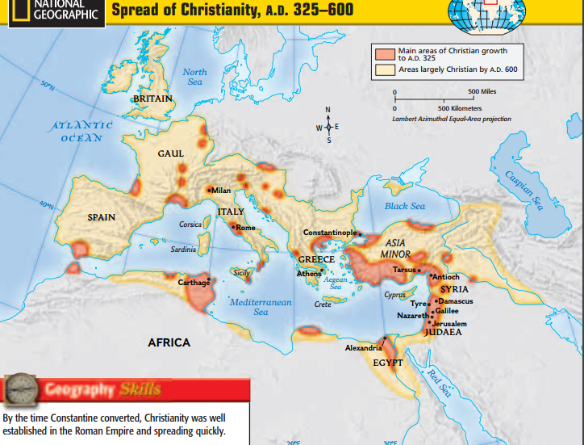

**Section 5. Decline and Fall**

1. **The Decline**

Marcus Aurelius, the last of the five good emperors, died in A.D. 180. A period of conflict and confusion followed.

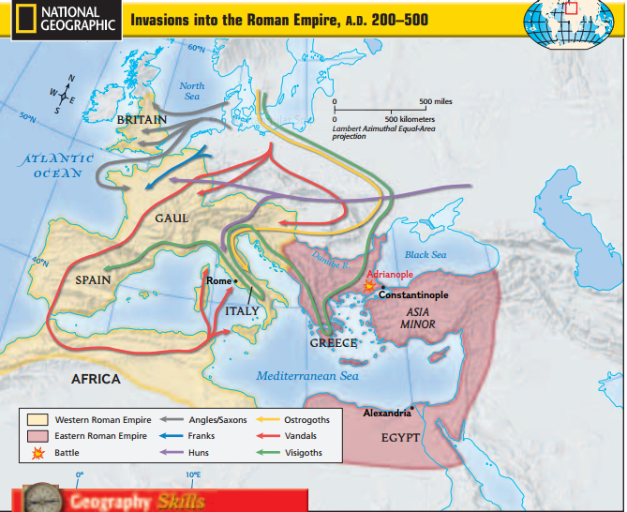

1. **Political Upheavals**

Following a series of civil wars, a military government under the Severan rulers restored order. Septimius Severus told his sons “to pay the soldiers, and ignore everyone else,” setting the tone for the new dynasty. After the Severan rulers there was a period of disorder. For almost fifty years, from 235 to 284, the Roman throne was occupied by whoever had military strength to seize it. During this period there were 22 emperors. Many of these emperors met a violent death.

At the same time, the empire was troubled by a series of invasions. In the east, the Sassanid Persians made inroads into Roman territory. Germanic tribes poured into the Balkans, Gaul, and Spain. Not until the end of the third century were most of the boundaries restored.

1. **Economic & Military Problems**

Invasions, civil wars, and plague came close to causing an economic collapse of the Roman Empire in the third century. There was a noticeable decline in trade and small industry. A labor shortage created by plague (an epidemic disease) affected both military recruiting and the economy. Farm production declined as fields were ravaged by invaders or, even more often, by the defending Roman armies. The monetary system began to show signs of collapse.

Armies were needed more than ever, but financial strains made it difficult to pay and enlist more soldiers. By the mid-third century, the state had to rely on hiring Germans to fight under Roman commanders. These soldiers did not understand Roman traditions and had little loyalty to either the empire or the emperors.

1. **Reforms of Diocletian & Constantine**

At the end of the third and the beginning of the fourth centuries, the Roman Empire gained a new lease on life through the efforts of two emperors, Diocletian and Constantine. The empire was changed into a new state: the Late Roman Empire, which included a new governmental structure, a rigid economic and social system, and a new state religion—Christianity.

Believing that the empire had grown too large for a single ruler, Diocletian, who ruled from 284 to 305, divided it into four units, each with its own ruler. Diocletian’s military power still enabled him to claim a higher status and to hold the ultimate authority. Constantine, who ruled from 306 to 337, continued and even expanded the policies of Diocletian.

Both rulers greatly strengthened and enlarged the administrative bureaucracies of the Roman Empire. A hierarchy of officials exercised control at the various levels of government. The army was enlarged to five hundred thousand men, including German troops. Mobile units were established to support frontier troops at threatened borders.

The political and military reforms of Diocletian and Constantine greatly enlarged two institutions— the army and civil service—which drained most of the public funds. More revenues were needed to pay for the army and bureaucracy. The population was not growing, however, so the tax base could not be increased.

Diocletian and Constantine devised new economic and social policies to deal with these financial burdens. To fight inflation—a rapid increase in prices— Diocletian issued a price edict in 301 that set wage and price controls for the entire empire. Despite severe penalties, it failed to work.

To ensure the tax base and keep the empire going despite the shortage of labor, the emperors issued edicts that forced people to remain in their designated vocations. Hence, basic jobs, such as bakers and shippers, became hereditary. The fortunes of free tenant farmers also declined. Soon they found themselves bound to the land by large landowners who took advantage of depressed agricultural conditions to enlarge their landed estates.

Constantine began his reign in 306, and by 324 he had emerged as the sole ruler of the empire. Constantine’s biggest project was the construction of a new capital city in the east, on the site of the Greek city of Byzantium on the shores of the Bosporus. The city, eventually renamed Constantinople (modern Istanbul in Turkey), was developed for defensive reasons and had an excellent strategic location. Calling it his “New Rome,” Constantine enriched the city with a forum, large palaces, and a vast amphitheater. Constantinople would become the center of the Eastern Roman Empire and one of the great cities of the world.

In general, the economic and social policies of Diocletian and Constantine were based on control and coercion. Although temporarily successful, such policies in the long run stifled the very vitality the Late Empire needed to revive its sagging fortunes.

1. **The Fall**

The restored empire of Diocletian and Constantine limped along for more than a century. After Constantine, the empire continued to be divided into western and eastern parts. The capital of the Western Roman Empire remained in Rome. Constantinople remained the capital of the Eastern Roman Empire. The Western Roman Empire came under increasing pressure from the invading Germanic tribes. The major breakthrough of invaders into the west came in the second half of the fourth century. The Huns, who came from Asia, moved into eastern Europe and put pressure on the Germanic Visigoths. The Visigoths, in turn, moved south and west, crossed the Danube River into Roman territory, and settled down as Roman allies. However, the Visigoths soon revolted. The Romans’ attempt to stop the revolt at Adrianople in

378 led to a crushing defeat for the Romans.

Increasing numbers of Germans now crossed the frontiers. In 410, the Visigoths sacked Rome. Another group, the Vandals, poured into southern Spain and Africa. They crossed into Italy from northern Africa and, in 455, they too sacked Rome. (Our modern word vandal is taken from this ruthless tribe.)

In 476, the western emperor, Romulus Augustulus, was deposed by the Germanic head of the army. This is usually taken as the date of the fall of the Western Roman Empire. As we shall see in Chapter 9, a series of German kingdoms replaced the Western Roman Empire. The Eastern Roman Empire, or the Byzantine Empire, however, continued to thrive with its center at Constantinople.

Many theories have been proposed to explain the decline and fall of the Roman Empire. They include the following:

• Christianity’s emphasis on a spiritual kingdom weakened Roman military virtues.

• Traditional Roman values declined as non-Italians gained prominence in the empire.

• Lead poisoning through leaden water pipes and cups caused a mental decline in the population.

• Plague wiped out one-tenth of the population.

• Rome failed to advance technologically because of slavery.

• Rome was unable to put together a workable political system.

There may be an element of truth in each of these theories, but each has also been challenged. History is an intricate web of relationships, causes, and effects. No single explanation can sufficiently explain complex historical events, such as the fall of a great empire.

For example, both the Han dynasty in China and the Roman Empire lasted for centuries. Both of these empires were able to govern large areas of land effectively. They instituted and maintained laws and a language. In spite of their attempts at unifying conquered territories, both empires experienced problems that came from acquiring so much land. Both tried to protect their borders with walls, forts, and troops. Both, however, eventually fell to invaders. The Han dynasty fell to the Xiongnu. The Roman army in the west was not able to fend off the hordes of people invading Italy and Gaul, and the Western Roman Empire fell. In contrast, the Eastern Roman Empire, which would survive for another thousand years, was able to withstand invaders.